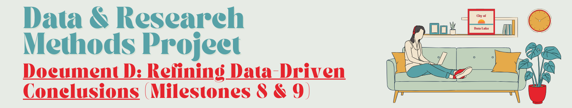

**Milestone 8 - Summarizing our Conclusions**

**~2 hours**

A senior colleague, Camille, asks you to write up your research conclusions. Camille is a Researcher and a Public Policy Strategist. Your conclusions for Camille should include at least two data-driven recommendations for the city of Data Lake. This summary will also be the basis for the research visualizations we develop for Milestone 9. 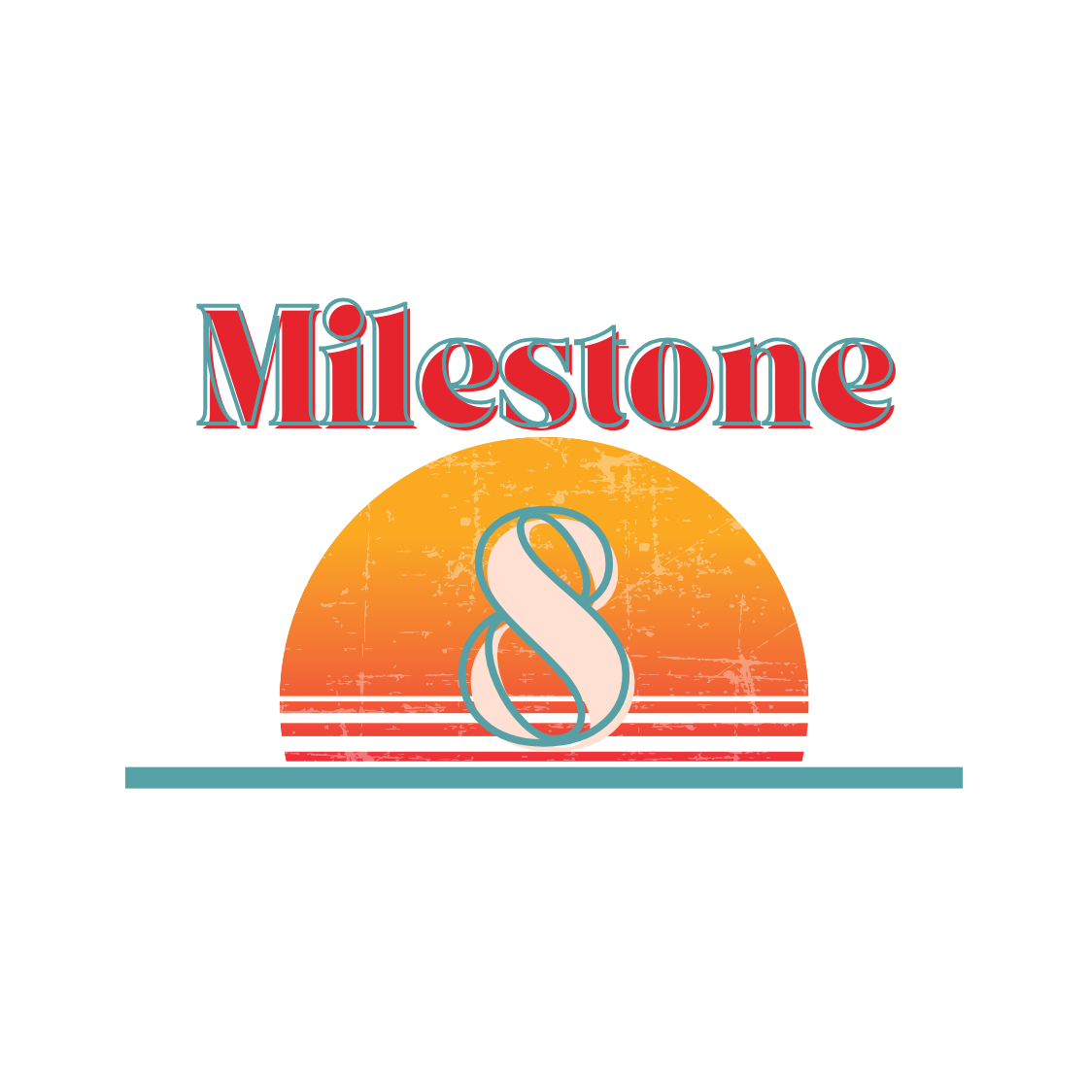

Before you get started, Camille suggests you take a look at the following resources:

* Learn to [tell a compelling data-driven story](https://online.hbs.edu/blog/post/data-storytelling).
* Further explore data storytelling with this [short video series](https://www.youtube.com/playlist?list=PLNs9ZO9jGtUDelmH4H34kMldFi7uWKuVc).

[****](https://youtu.be/sQJfSIfHauI)

[**Video Link**](https://youtu.be/sQJfSIfHauI)

Task 17: Summarizing Initial Conclusions

Review your research findings from Milestone 7. Now, let’s tie those findings together for the Office of the Mayor. Write down some initial responses to the below questions and use your answers to shape your written summary below. Some of these are questions the Mayor and her staff are likely to ask you in a meeting. 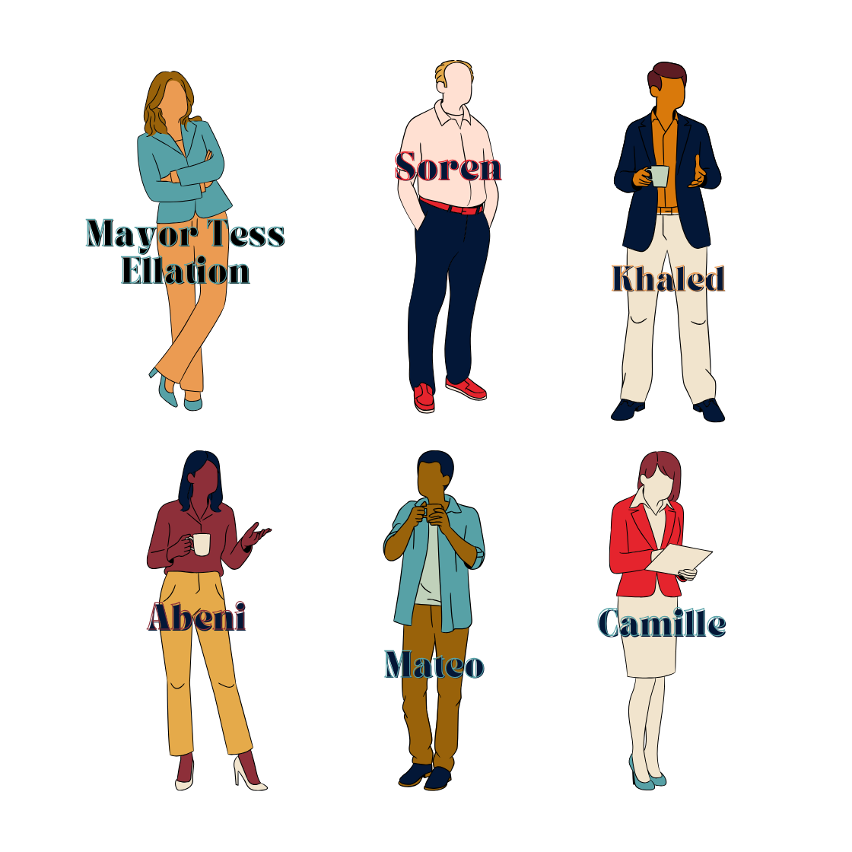

1. Do your four findings from Task 16 support your initial hypothesis from Task 14? Why or why not? (What happens if your data doesn’t align with your initial hypothesis? That means you’ve learned something new! “[Scientific failure](https://www.science.org/content/article/why-i-teach-my-students-about-scientific-failure)” is an important part of the research process - don’t get discouraged, your work is still valid and important.) *Write 2-4 sentences.*

|  |
| --- |

1. How certain are you that these findings (Task 16) support your hypothesis (Task 14)? What other data variables not represented in the Census Bureau’s dataset (e.g., the participants’ professional background, their religion, their political affiliation, etc.) might challenge your insights? *Write 2-4 sentences.*

|  |
| --- |

1. What was your methodology for collecting these insights? (Review Milestone 6.) *Write 2-4 sentences.*

|  |
| --- |

1. What other evidence would you want to see to be fully convinced of your hypothesis? What type of data would you need to perform that research? Who would collect that data and how (e.g., [Focus Groups](https://www.urban.org/research/data-methods/data-collection/focus-groups), [In-Depth Interviews](https://www.driveresearch.com/market-research-company-blog/what-are-idis-in-depth-interviews-market-research/#:~:text=In%2Ddepth%20interviews%2C%20or%20IDIs,from%20individuals%20or%20small%20groups.), or additional surveys)? *Write 2-4 sentences.*

|  |
| --- |

1. How might your findings inform the city’s future policies, budget, or economy? What are your two data driven recommendations for the city of Data Lake? *Write 2-4 sentences.*

|  |
| --- |

1. Does your research raise new questions? If you had complete scientific freedom, what question about the American workplace would you tackle next? If you have specific ideas about datasets or resources you’d use to explore those ideas, feel free to mention them. *Write 2-4 sentences.*

|  |
| --- |

Task 18: Drafting an Executive Summary

Tackling all of these points above (as well as whatever else you think is relevant), write at least 10-12 sentences on your initial conclusions in the form of an Executive Summary.

Begin by learning more about what an [Executive Summary](https://www.indeed.com/career-advice/career-development/executive-summary-research-paper) (ES) is. A research paper ES helps upper management understand your insights at a glance. You are distilling your critical insights and prompting action based on your analysis. The key purpose of an ES is to save your readers time by highlighting essential information. The proper format for your ES is:

* Purpose of study - a very brief summary of the aims of your report (e.g., this study was requested as the City of Data Lake has seen a recent uptick in the number of residents who are working remotely).
* Methods to gather your data - a description of the processes used to compile and analyze your data (e.g., your data was pulled from the Census Bureau, you began with an analysis of the survey questionnaire, then did an in depth analysis of the quantitative data).
* Findings - a description of your findings (e.g., remote workers’ children are more prone to anxiety - note, this is purely an example).
* Recommendation - your two recommendations for Mayor Ellation based on your findings.
* Report Limitations - any additional factors or limitations that may impact your study (e.g., the data is self-reported and does not include insights from the childrens’ teachers or other community members).
* Implementation - any guidance you may want to share to effectively implement your recommendations (e.g., increase the % of Data Lake’s budget for education).
* Conclusion - a one sentence summary of your points.

|  |
| --- |

Tips:

* Set your writing aside and come back in a few days with fresh eyes. Revise as necessary.
* Whenever possible, you should use data or information from your desk research to support your arguments. Cite your research as appropriate - it’s a good idea to get into the habit of using APA (a resource for [citing data in APA style](https://apastyle.apa.org/style-grammar-guidelines/references/examples/data-set-references), a resource for [the basics of APA citations](https://apastyle.apa.org/style-grammar-guidelines/citations/basic-principles/author-date)).
* Think about the key points you want to share with your audience. What specific insights do you want someone to take away from your research? What did you find that made you say “wow!”? You’ll further explore the wow factor of your research in Milestone 9.

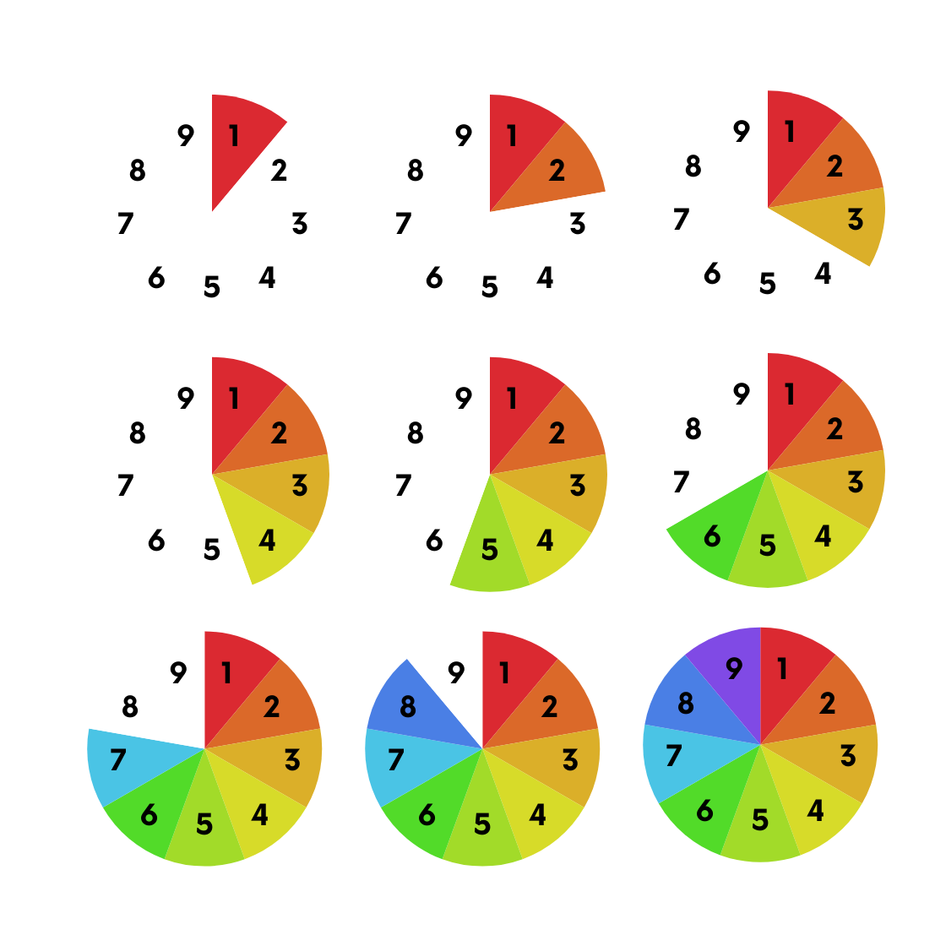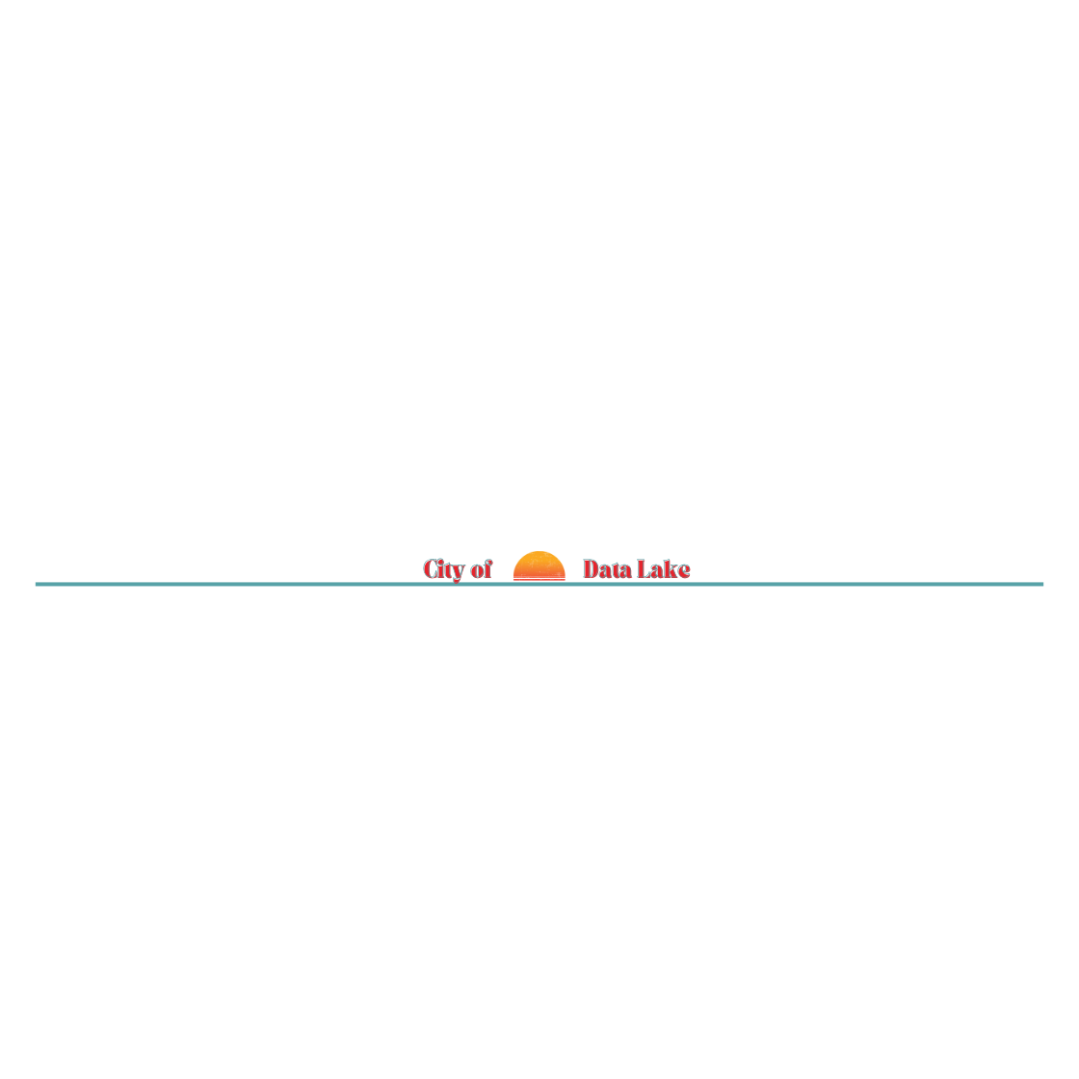

**You’ve completed the 8th Milestone!**

Great work! This Milestone required a lot of effort, but your written summary will help you with the final stage of your project - building data visualizations and refining your analysis.

**Next Steps:**

We recommend taking a short break from your research so you can come back to Milestone 9: Visualizing our Findings with fresh eyes. Give it a day or two, then come back to round off your analysis with some visualizations that will really drive your ideas home.

**Milestone 9 - Visualizing our Findings**

**~2 hours** 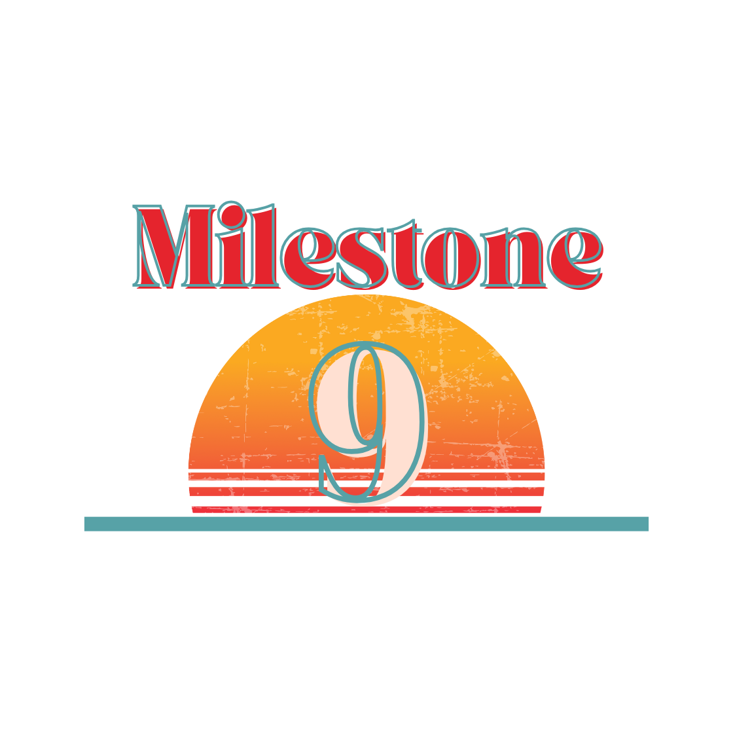

Camille thinks your research summary looks great! She recommends that you also develop three visualizations which highlight key points noted in your summary.

[****](https://youtu.be/l8RCO-EFWc8)

[**Video Link**](https://youtu.be/l8RCO-EFWc8)

Identifying Target Audiences

Before we do any visualization work, we should remind ourselves of who we will be sharing this information with. We would explain our findings to a friend in a different way than a professor or government official. Remember that this material is going to Mayor Ellation and her public policy team. They very likely have a limited attention span and will be looking for clearly identifiable talking points. Our visualizations will have to be compelling, clear, and understandable.

Exploring Visualization Types

There are many types of [chart types](https://datavizcatalogue.com/) (e.g., stacked area charts, bubble charts, etc.), but not all visualizations will work perfectly for your research.

* [Decide which visualization type is most appropriate for your research question](https://chartio.com/learn/charts/how-to-choose-data-visualization/). Compare types and how they communicate specific ideas or trends.
* If necessary, go back to Milestone 6 for a refresher on the various types of visualizations and charts you can build in Google Sheets / Excel.

Accessible Visualizations

Consider [how your visualization might appear to people with disabilities](https://chartability.fizz.studio/) who may not be able to distinguish between muted colors or see your chart at all. Are there any changes you can make so that differently-abled scientists can also learn about your research? Some tools include:

* + [Color Contrast Checker](https://policyviz.com/2022/11/01/color-contrast-checker-in-excel/)
  + [SAS Graphics Accelerator](https://support.sas.com/software/products/graphics-accelerator/index.html)
  + [TwoTone Data Sonification Tool](https://twotone.io/about/)
  + [Making Visual Studio Accessible](https://code.visualstudio.com/docs/editor/accessibility)

Task 19: Identifying Key Messages

Camille asks you to create three visualizations for the Mayor and her team. Before getting started, take a moment to think carefully about the connection between your hypothesis and the “wow!” insights you noted in Milestone 8. What key points should be pulled from your analysis? What are your two data-driven recommendations for the city of Data Lake? What chart types would help you explain those recommendations in an interesting way?

Use the below space to write out some initial notes or thoughts about what types of visualizations you’d like to use and why.

|  |
| --- |

For data storytelling, it’s better to have three very compelling charts than ten, similar-looking bar charts. You also want your charts to make sense to the viewer and quickly tell your story. A great (and amusing) data story which uses three distinct chart types can be found at [NYC Slice](https://elkue.com/nyc-slice/). The first chart grounds our geospatial understanding, the second gives us a sense of change over time, and the third lets the user browse by year, type, and cost. Take a look at this resource as you think about your final presentation.

Task 20: Developing Data Visualizations

Now we come to the fun part! Give yourself plenty of time to build your three visualizations. We encourage you to use the simple charts and graphs which you can build in Google Sheets / Excel to develop your visualizations. However, if you would like to stretch yourself, please feel free to use other tools (e.g., Tableau) for this Task. The goal here is not necessarily to create a “pretty” visualization, but rather, a clear and effective visualization which accurately reflects your analysis.

Save your visualizations and/or any links. These are part of your final submission for this project.

This Milestone is very open-ended and we can’t wait to see your unique approach to data visualizations! Come back here when you’re done.



**You’ve completed the 9th Milestone!**

Your team has submitted your final analysis to Mayor Ellation for consideration. Great job pulling together some data driven recommendations for the City of Data Lake. Congratulations on all of your hard work!

**Next Steps:**

We can’t wait to read your project! [Submit your final materials to the NSDC via this Google Form](https://forms.gle/KuBBH5s9MPD6PfGUA). Your final submission materials should include:

* Your completed versions of Documents A, B, C, and D
* Your completed Data file, including any visualizations, pivot tables, or other data you have created during this project

Any final questions? Email [lc3460@columbia.edu](mailto:lc3460@columbia.edu) for additional guidance on your submission.